

**COMSATS University Islamabad (CUI)**

Project Proposal   
(SCOPE DOCUMENT)

For

**Speech2face**

Version 1.0

**Assignment-01**

**BCS-4-B**

***By***

**Shahzaneer Ahmed CIIT/SP21-BCS-087/ISB**

**Shayan Zameer CIIT/ SP21-BCS-088/ISB**

***Supervisor*  
Mr. Tehseen Riaz Abbasi**

***(Date of Submission: 6th November, 2022)***

*Bachelor of Science in Computer Science (2021-2025)*

**SCOPE DOCUMENT REVSION HISTORY**

|  |  |  |
| --- | --- | --- |
| **No.** | **Comment** | **Action** |
|  |  |  |
|  |  |  |
|  |  |  |
|  |  |  |
|  |  |  |
|  |  |  |

**Supervisor Signature:**

**Date:**

Contents

Abstract 1-iv

1. Introduction 1-iv

2. Problem Statement 2-iv

3. Problem Solution for the Proposed System 3-v

3.1 Objectives 3-v

4. Vision Statement 4-v

5. Related System Analysis/Literature Review 5-v

5.1 Table 1: Similar Systems like Speech2Face 5-vi

6. Advantages/Benefits of Proposed System 6-vii

7. Project Scope 7-vii

8. Modules 8-viii

8.1 Module 1: Profile Management 8-viii

8.2 Module 2: Place Voice Record 8-viii

8.3 Module 3: Sound to Face Vector Model 8-viii

8.4 Module 4: Face-Vector to Face-Image Model 8-viii

8.5 Module 5: Image View Customization 8-ix

8.6 Module 6: Features Enhancer 8-ix

8.7 Module 7: Insight Panel 8-ix

8.8 Module 8: Feedback Panel 8-ix

8.9 Module 9: Help and Support 8-ix

9. System Limitations/Constraints 8-x

10. Software Process and Design Methodology 10-x

11. Data Gathering Approach 11-x

12. Learning Concepts 12-xi

13. Tools and Technologies 13-xi

14. Project Stakeholders and Roles 14-xii

Table 3: Stake Holders of Speech2Face 14-xiii

15. Module based Work Division Among Team Members 15-xiii

Table 4: Team Member Work Division the Targeted Project. 15-xiii

16. WBS and Gantt Chart 16-xiii

17. Mockups 17-xviii

18. Conclusion 18-xviii

19. References 19-xix

19.1 Related System: 19-xix

19.1.1 https://www.github.com/topics/sound-classification. 19-xix

19.1.2 https://speech2face.github.io/ 19-xix

19.1.3 Google Facenet 19-xix

19.2 YouTube Resources: 19-xix

19.2.1 https://www.youtube.com/watch?v=aKYlSIs3UDY&t=334s 19-xix

20. Plagiarism Report 20-xix

21. Scope Document Work-Division 21-xix

**Project Category:**

□ **B-**Web Application/Web Application based Information System □ **C-**Problem Solving and Artificial Intelligence

□ **E-**Smartphone Application

□ **H-**Image Processing

# 

# Abstract

Speech2face is a web and mobile application-based software that is mainly built to recognize the face general structure, ethnicity and gender with the audio waves. Currently there is

no full fledge software in the world that helps in this regard although there are deep learning libraries on which much work is done in the past. It was nearly impossible to predict the appearance of some person with his/her voice. But Artificial Intelligence has made it.

It will automate the attendance system and reinvigorate the authentication system. Moreover, it will prove itself as an asset to the security and intelligence agencies by recognizing criminals faces with the voice notes and eventually help them resolving complex cases.

Speech2face can also be used as a general-purpose software for recognizing the individuals in old audios and images where their appearance is not clear.

# Introduction

Recognizing the facial features of a person based on their audio notes by a human being who don’t actually know the person make no sense in real life. There is no such way to do something like this. Every prediction will be a wild guess with zero or no reliability at all. But with the advent in the Technology, Artificial Intelligence has made it possible to do so. The Machine Learning and Deep Learning Models can be trained on data of all type of people with some mathematical perspectives of voice that use clustering algorithms and categorize the people in different domains. By doing so, they generate predicted images.

The images will not be 100% real. But they can give a lot of insights of the data which can help us identify the person.

# Problem Statement

There are many loop holes in the user authentications used in the security systems including banks, critical profile accounts and many more places where authenticity should be the first and foremost priority. Every other person who has the credentials of the account of that specific user can log into the accounts specified merely for the former. Secondly In most of the criminal scenes it is observed that the faces are not recognized and hence the criminals are not capture by the security forces. There is always a hindrance in the recognizing of the culprits involved in the crime scene. Mostly the voice can be seen but the faces are under the veil and thus cannot be seen directly. Market has no such software that provides such facilities at the same place as utilities.

# Problem Solution for the Proposed System

Many Application users and Agencies have requested systems that are helpful, efficient, and reliable in user authentication. People have asked to ensure the dependability and security of critical accounts. Speech2face will provide an acceptable solution to these concerns. Security and intelligence agencies face many complications in identifying criminals as in most cases their faces are not revealed by the camera. They cannot give their visual representation to the security forces to capture them and mark them wanted. Speech2face will help us in this regard. Moreover, the old audio and video notes can be used to find insights about the person’s basic information.

## Objectives

*O-1: Authenticate the user login system by 50%*

*O-2: Assist Intelligence Agencies and security forces to identify the criminals by 60%*

*O-3: help to retrieve the images with audio/video by 50%*

# Vision Statement

For users (generic, intelligence agencies) who want to authenticate their user systems and find a visual representation (facial view) of voices depending upon different factors, the Speech2face is an internet-based and smartphone-enabled application that will help in authenticating the users and finding real-time insights about voices unlike the data analyzed models which are not in practical usage form, the users who will use our speech2face system will be able to transform the audios into images and gain generic information about the person whose voice is under observation.

# Related System Analysis/Literature Review

Following are some existing apps related to our project:

**Sound Classification:**

Audio Classification is the practice of examining audio recordings. The project classifies the sound into different categories e.g., environmental sound, the voice of speech, music sound, etc. Several AI and Data Science applications including chatbots, automatic voice translators, text to speech software can be created through this technology.

The link to their website is https://www.github.com/topics/sound-classification.

**Traffic Signs Classification:**

We have many kinds of traffic signs which we see in our daily life such as turning left or right, No passing heavy vehicles, indicating speed, etc. Traffic Signs classification is the process of figuring out which class a traffic sign belongs to.

**Speech2Face:**

Speech2Face is all about guessing a person's Face using voice. In this project, we are trying to reconstruct the facial image of a person from a short audio recording of that person speaking.

The link to their website is <https://speech2face.github.io/>.

**Facenet:**

Facenet is a project developed by three researchers at Google. Face.net basically takes a face and turns it into a vector of 128 values. The project is designed to produce an embedding from a face of a person.

Table ***1***provides the weakness of these apps and proposed solutions that would be done in this project.

## Table 1: Similar Systems like Speech2Face

|  |  |  |
| --- | --- | --- |
| **Application Name** | **Weakness** | **Proposed Project Solution** |
| ·Sound Classification | ·      There are too many sounds so There is a possibility that the system can’t get sound and displays results according to to need. | ·      The project deals with speech recognition and converts facial images. The risk is low as compared to related projects. |
| Face.net | . There are a number of areas that are still left to be explored and how different ages and races play a role in face recognition. | . |
| ·Speech2Face | ·       No, Mobile application, only available as a website. | ·       The application will be available on the web as well as a mobile application. |

# Advantages/Benefits of Proposed System

* Privacy of a person is there because the resemblance is apparently not 100% right.
* This application helps the investigation team to get an idea of what the criminals look like by using their voices.
* We evaluate and numerically quantify how and in what matter reconstruction from audio resembles the true face of images of the speaker.

# Project Scope

**Speech2Face** will be a Research and development-based Product with the main functionality to convert the voice into vector form and the vector form to image form and thus assisting in providing insights about the details of the person whose voice is under observation. It will be developed using different technologies and Deep Learning and machine learning techniques will be used. The Image generated can be modified in accordance with the users’ perspective

**General user**: They can retrieve their images from their voice notes.

**Security Agencies**: It Can help them identify the criminals and speed up the process of resolving complex cases.

. A bird's eye view of the Project is given below:

**Figure 1: Context Diagram of Speech2Face**

# Modules

## Module 1: Profile Management

**M1F1:** Sign up

**M1F2:** Login

**M1F3:** Sign in Via Phone

**M1F4:** Sign in as a Guest

**M1F5:** Sign in Via Voice

**M1F6:** Update Profile Information

**M1F7:** Delete Profile

**M1F8:** Logout

## Module 2: Place Voice Record

**M2F1:** Record Voice

**M2F2:** Upload Existing Voice

**M2F3:** Upload Existing Video to fetch Voice

**M2F4:** Update Voice

**M2F5:** Update Video

**M2F6:** Delete Voice

**M2F7:** Delete Video

## Module 3: Sound to Face Vector Model

**M3F1:** Sound to vector Modeling via Deep Learning

**M3F2:** Generate Vector Model

## Module 4: Face-Vector to Face-Image Model

**M4F1:** Vector to Image Modeling via Deep Learning

**M4F2:** Generate Image Model

## Module 5: Image View Customization

**M5F1:** Brightness Control

**M5F2:** Saturation Management

**M5F3:** Skin Color Management

**M5F4:** Filters

## Module 6: Features Enhancer

**M6F1:** Face Shape Enhancement

**M6F2:** Nose Enhancement

**M6F3:** Eyebrow Enhancement

**M6F4:** Beard Maker

**M6F5:** Eye Enhancement

## Module 7: Insight Panel

**M7F1:** View Report

**M7F2:** Download Report

**M7F3:** Share on Socials

## Module 8: Feedback Panel

**M8F1:** Rate Result

**M8F2:** Feedback in terms of words

**M8F3:** System Lagging Checks

## Module 9: Help and Support

**M9F1:** Chat with AI Bot

**M9F2:** Contact Support Team

**M9F3:** Change Bots-Language

**M9F4: View Bot’s Query History**

# System Limitations/Constraints

Following are the limitations of our proposed system:

1. The system cannot predict the image 100% right.
2. The system is unable to guess some voices if it consists of the type on which the data is not trained. It is the limitation of AI.
3. The System can be accessed over the internet only.

# Software Process and Design Methodology

The software process model which we will be following for this project is **Iterative Process Model.** Our application has finite number of functionalities and most of the requirements are not surely known as the project is not very common in market and it is research and development based. Therefore, the most suitable process model we could select is iterative process model so that we may go back to the requirement or design phase when the need arrives.

The design methodology we will be using is **Object Oriented Programming Approach** because it increases the reusability of the code, reduces the complexity of the code, and it would be easier for the team members to work together without any confusion as it is the most followed programming paradigm in the market.

Therefore, we are using Dart for Flutter (Mobile-end) and JavaScript (Web-end) for Web which follows object-oriented approach. Also, it is easier to describe the code using Unified Modeling language diagrams.

# Data Gathering Approach

The data gathering for requirement analysis adopted for the proposed system includes surveys and interviews with the general users, intelligence agencies, and security forces.

However, the data set which was trained was obtained from the Open Source Kaggle platform which consists of voice interpretation insights of different peoples of the world with their corresponding facial features.

# Learning Concepts

The concepts that we would be learning are

**Concept-1: UI/UX Designing via Figma:**

firstly, we will develop the UI of the system for both web and mobile interfaces.

**Concept-2: Flutter for Mobile App Development:**

For Mobile-end, we are using Flutter SDK. We will be learning to change the UI in Flutter code using Dart.

**Concept-3:** **HTML, CSS, and JS for Web Development:**

For Web-end, we are going to use vanilla HTML for web structuring, CSS for design, and JS for client-side scripting

**Concept-4:** **Firebase for user Authentication and Data Storage:**

We will also implement backend using firebase for authentication and data storage using firestore database and firebase Auth package.

**Concept-5:** **Data Analysis using Numpy, Pandas, and Matplotlib:**

For the initial Data analysis of the data set we will use the power of python packages for statistical computations and visualization of the data.

**Concept-6: Machine Learning and Deep Learning using Tensorflow and Keras:**

The data set will be trained by using machine learning techniques using Python libraries for Data modeling.

# Tools and Technologies

The tools and technologies that we will be using are provided in the ***Table 2*** below. The main IDE tool to develop the code will be **Microsoft** **Visual Studio Code 2022** on which different Technologies like **Flutter, HTML-CSS** and **Java Script** will be implemented. **Figma** will be used for mockup creation. **Microsoft** **Word** and **PowerPoint** will be used for documentation and presentation. **Firebase** Firestore will be used as the backend database.

|  |  |  |  |
| --- | --- | --- | --- |
| **Tools**  **Technologies** | **Tools** | **Version** | **Rationale** |
| Visual Studio Code | 2022 | IDE |
| MS Word | 2021 | Documentation |
| MS Power Point | 2021 | Presentation |
| Figma | 2022 | Mockups Creation |
| Flutter | 3.3 | SDK |
| Git | 4.3 | VCS |
| Netlify |  | Deployment |
| **Technology** | **Version** | **Rationale** |
| Dart | 3.5 | Client-side Scripting |
| Firebase | 5 | Ready Made Backend |
| Html | 5 | Web Structuring |
|  | CSS | 3 | Web Design |
|  | Tailwind CSS | 3.0 | Web Design |
|  | Bootstrap | 5 | Built-in Web Components |
|  | JavaScript | ECMA Script 2017 | Event Based Programming language |
|  | Python | 3.8 | ML/DL Modeling |

**Table 2: Tools and Technologies for the Speech2face.**

# Project Stakeholders and Roles

The stakeholders of the project comprise of both the Software Engineers working on the project from the development and documentation side. The project will be developed in the supervision of **Mr. Tehseen Riaz Abbasi** and for the evaluation of the project, there will be a Final Evaluation Project Committee. The key roles of the stakeholders are:

* **Shahzaneer Ahmed:**  Responsible for Development, Documentation, and Design.
* **Shayan Zameer:**  Responsible for Development, Design and Testing.

|  |  |
| --- | --- |
| **Project Sponsor** | RaviCom Solutions Private Limited. |
| **Stakeholder** | * Shahzaneer Ahmed * Shayan Zameer * Project Supervisor Name: Mr. Tehseen Riaz Abbasi. * Final Year Project Committee: Evaluation of project. |

# Table 3: Stake Holders of Speech2Face

# Module based Work Division Among Team Members

|  |  |  |
| --- | --- | --- |
| **Name** | **Registration Number** | **Responsibility/ Modules** |
| * **Shahzaneer Ahmed** | * **SP21-BCS-087** | * **(Module1-Module3-Module6-Module7)**   Mobile App, Documentation, Backend, ML/DL |
| * **Shayan Zameer** | * **SP21-BCS-088** | * **(Module2-Module4-Module5-Module8)**   Web A, Documentation, Artificial Intelligence, Deign |

# Table 4: Team Member Work Division the Targeted Project.

# WBS and Gantt Chart

|  |  |  |  |  |
| --- | --- | --- | --- | --- |
| **ID** |  | **Task** | **Duration** | **Resources** |
| **1** | **Planning/System Feasibility** | | **8 d** | **Shahzaneer , Shayan** |
| 2 |  | Idea Discussion | 4 d | Shahzaneer, Shayan |
| 3 |  | Scope Document | 3 d | Shahzaneer |
| 4 |  | Scope Submission | 1 d | Shahzaneer |
| **5** | **Requirement Engineering** | | **22 d** | **Shahzaneer , Shayan** |
| 6 |  | Requirement Gathering | 7 d | Shahzaneer , Shayan |
| 7 |  | Requirement Analysis | 3 d | Shayan |
| 8 |  | Requirement Definition | 5 d | Shayan |
| 9 |  | SRC Document | 7 d | Shahzaneer |
| **10** | **Design And Analysis** | | **45 d** | **Shahzaneer , Shayan** |
| 11 |  | Database Design | 12 d | Shahzaneer |
| 12 |  | Interface Design | 7 d | Shayan |
| 13 |  | Machine Learning Implementation | 5 d | Shahzaneer , Shayan |
| 14 |  | SDS | 1 d | Shahzaneer |
| 15 |  | Finalizing Design And Validation | 8 d | Shahzaneer |
| 16 |  | Conversion Of Speech To Vector | 6 d | Shahzaneer |
| 17 |  | Features Enhancer | 6 d | Shayan |
| **18** | **Development** | | **15 d** | **Shahzaneer , Shayan** |
| 19 |  | Scope Development | 1 d | Shahzaneer |
| 20 |  | Create Frontend | 15 d | Shayan |
| 21 |  | Create Backend | 6 d | Shahzaneer |
| 22 |  | Initial Testing | 1 d | Shayan |
| 23 |  | Development Finished |  |  |
| **24** |  | **Testing** | **8d** | **Shahzaneer,Shayan** |
| 25 |  | System Testing | 2d | Shayan |
| 26 |  | Error Detection | 1d | Shayan |
| 27 |  | Error Resolution | 3d | Shahzaneer |
| 28 |  | Error Evaluation | 2d | Shahzaneer |
| **29** |  | **Deployment** | **1d** | **Shahzaneer** |
| 29 |  | Deployment Application | 1d | **Shahzaneer** |
| **30** |  | **Completion** | **3d** | **Shayan, Shahzaneer** |
| 31 |  | Evaluation | 3d | Shayan, Shahzaneer |
| 32 |  | Completion |  |  |

**Table 5: WBS for software development.**

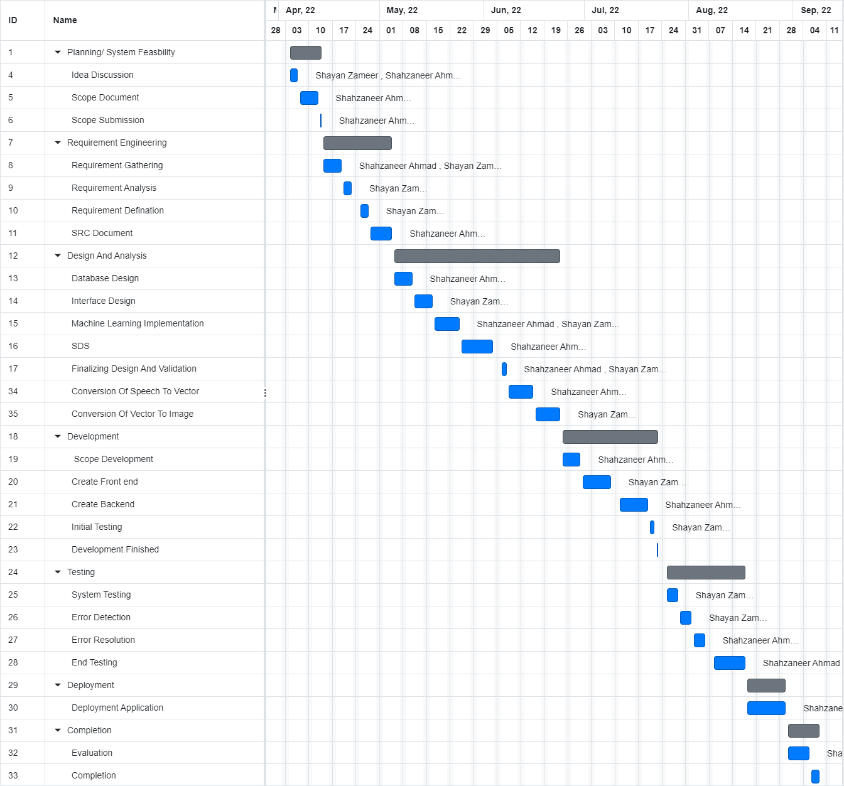

Figure 2: Gant Chart for software development

# Mockups

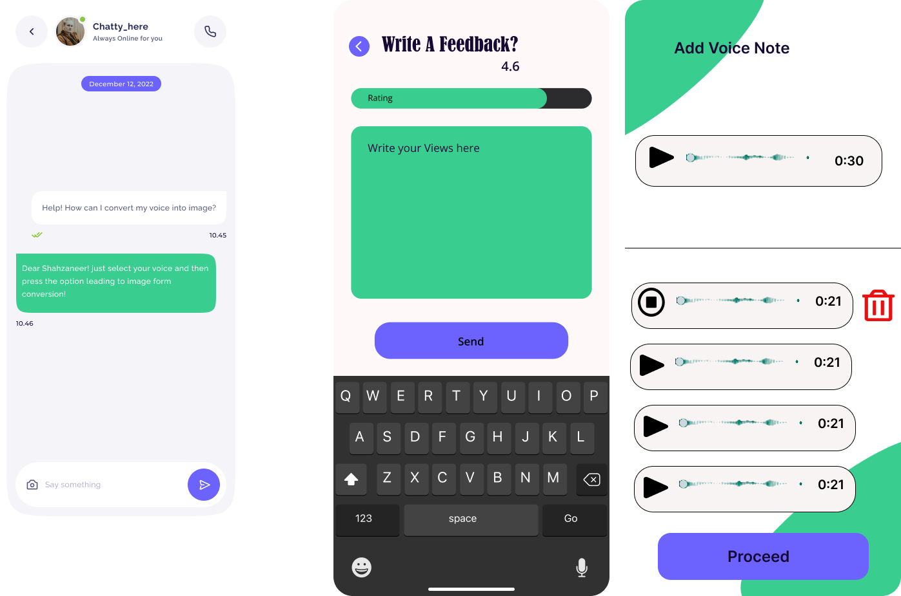

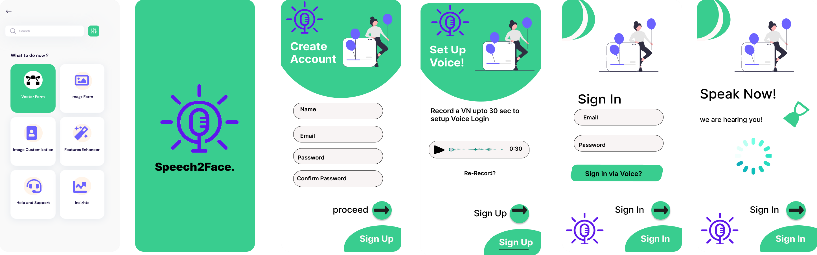

# Conclusion

The Speech2Face’s ultimate objective is to help users to authenticate their logins and sign-ups. It helps to retrieve images based on voices firstly in vector form and then by converting them into image form. It also helps intelligence and security agencies to identify the culprits and criminals on the basis of their voices. It won't generate real images but is very helpful in generating specific insights.

Nonetheless, this project will serve as a solid foundation for getting acuities via speech and it will give an amazing experience of authentications for the users.

# References

## Related System:

### <https://www.github.com/topics/sound-classification>.

### <https://speech2face.github.io/>

### [Google Facenet](https://www.geeksforgeeks.org/facenet-using-facial-recognition-system/%23:~:text=FaceNet%20is%20the%20name%20of,for%20Face%20Recognition%20and%20Clustering.)

## YouTube Resources:

### https://www.youtube.com/watch?v=aKYlSIs3UDY&t=334s

# Plagiarism Report

* N/A

# Scope Document Work-Division

**Table 6: Work Division**

|  |  |
| --- | --- |
| **Shahzaneer Ahmed**  **(SP21-BCS-087)** | **Shayan Zameer**  **(SP21-BCS-088)** |
| 1. Abstract 2. Introduction 3. Problem Statement 4. Problem Solution for the proposed system and Objectives 5. Vision Statement 6. Modules 7. System Limitations/Constraints 8. WBS and Gantt Chart 9. Conclusion 10. Final Format Preparation of Scope Document (Word .docx file) | 1. Related System Analysis/Literature Review 2. Advantages/Benefits of Proposed System 3. Project Scope 4. Software Process and Design Methodology 5. Tools and Technologies 6. Project Stakeholders and Roles 7. Work Division 8. Concepts 9. Mockups 10. Presentation (PowerPoint .ppt file) |